Assessment:

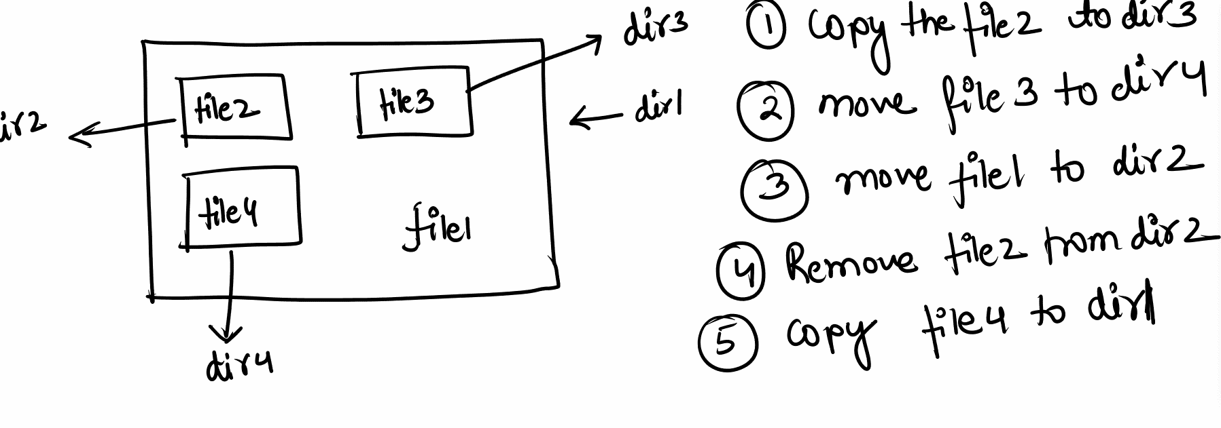



mkdir dir1/dir2 dir1/dir3 dir1/dir4

ls dir1





touch dir1/file1 dir1/dir2/file2 dir1/dir3/file3 dir1/dir4/file4

>> copy file2 to dir3

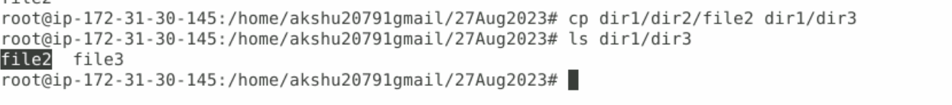

cp dir1/dir2/file2 dir1/dir3

ls dir1/dir3

## move file3 to dir4

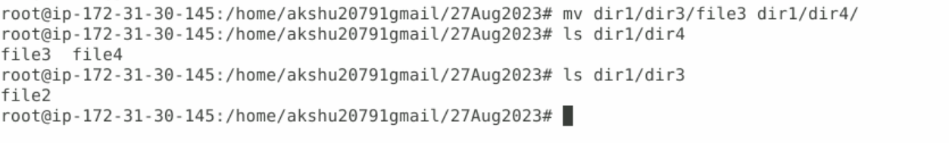

ls dir1/dir3

(you will see file3 is present)

mv dir1/dir3/file3 dir1/dir4/

mv dir1/dir3/file3 dir1/dir4/

ls dir1/dir3

(in this command you will see the file3 is not there in dir3)

###move file1 to dir2

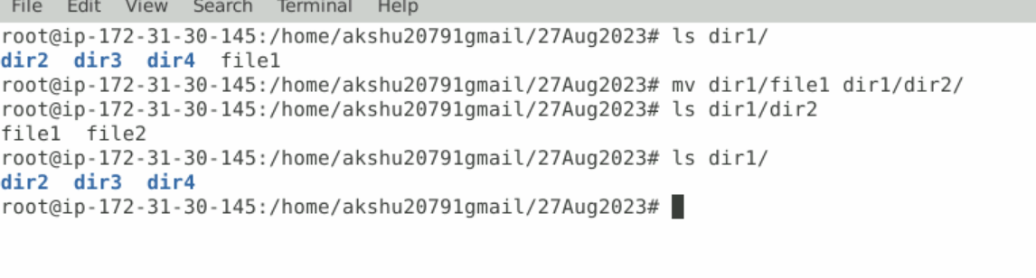

ls dir1/

mv dir1/file1 dir1/dir2/

ls dir1/dir2

ls dir1/

### remove file2 from dir2

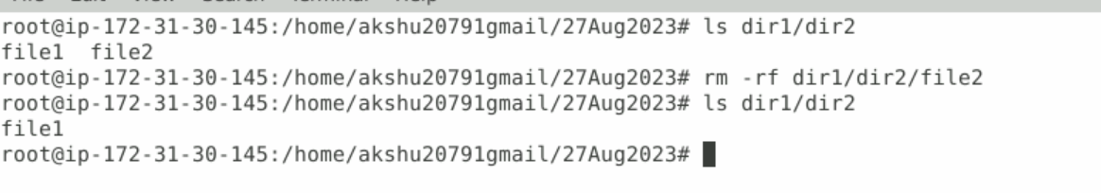

In above screenshot see the file2 is removed from dir2

ls dir1/dir2

rm -rf dir1/dir2/file2

ls dir1/dir2

###Copy file4 to dir1

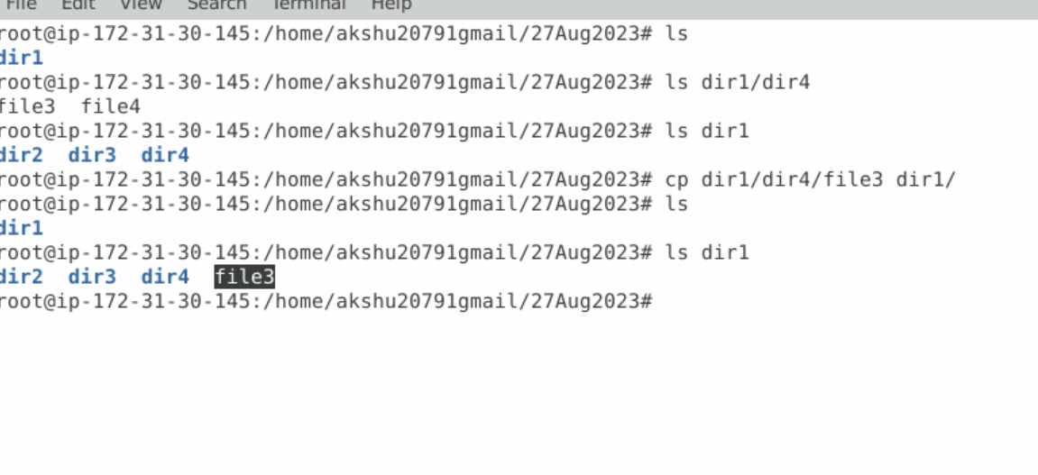

ls dir1/dir4

ls dir1

cp dir1/dir4/file3 dir1/

ls dir1